- Test Dataset: 10100AA158006
S‐158 Recommended ENC Validation Checks covered in this section:
S‐158 Check | Description
101_1240 | For each Wreck OR Obstruction OR UnderwaterAwashRock where valueOfSounding is Unknown AND defaultClearanceDepth is Unknown.
101_1254 | For each Obstruction feature of geometric primitive curve where categoryOfObstruction Equal to 23 (mangrove).
101_1408 | For each Chart1Feature within the dataset.
101_1268 | For each Obstruction OR Wreck where valueOfSounding is Present AND height is Present.
101_1252 | For each Wreck where valueOfSounding is not Present AND categoryOfWreck is not Present.

Secondary Errors
Critical – 1 (101_1005)
Error – None
Warnings – None

Dataset Name | 10100AA158006 |  | S‐158 Check |  | 101_1240 |  |  | Type |  | C
S-158 Description | For each Wreck OR Obstruction OR UnderwaterAwashRock where valueOfSounding is Unknown AND defaultClearanceDepth is Unknown.
Message | Feature where attributes valueOfSounding and defaultClearanceDepth are Unknown.
Solution | Populate valueOfSounding or defaultClearanceDepth |  |  |  | Conformity |  | PS 13.4, 13.5, 13.6
Test Case No. 1 | valueOfSounding and defaultClearanceDepth are not populated on an Obstruction.
Location | Feature | Attributes |  | FRID |  | FOID |  |  | VRID
32.4974355S, 61.5084290E | Obstruction | categoryOfObstruction = 23  valueOfSounding = (Unknown)  waterLevelEffect = 4  defaultClearanceDepth = (Unknown)  surroundingDepth = 0 m |  | 74 |  | 1810:8678:1 |  |  | -
Screen Capture | 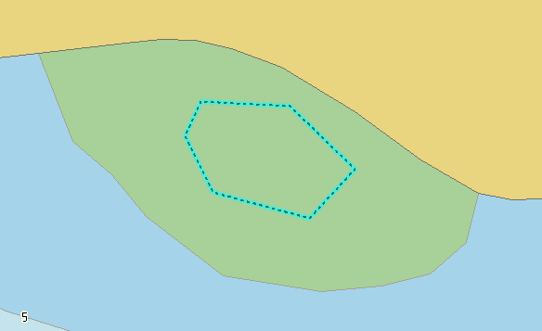
Expected Test Results | 101_1240: An error “Feature where attributes valueOfSounding and defaultClearanceDepth are Unknown.” must be triggered.
Secondary Critical Errors | None

Dataset Name | 10100AA158006 |  | S‐158 Check |  | 101_1254 |  |  | Type |  | C
S-158 Description | For each Obstruction feature of geometric primitive curve where categoryOfObstruction Equal to 23 (mangrove).
Message | Obstructions features of geometric primitive curve where categoryOfObstruction = 23(mangrove) is prohibited.
Solution | Encode as Obstruction of geometric primitive surface covered by intertidal area; or encode the seaward edge of the mangrove as Coastline bounding LandArea. |  |  |  | Conformity |  | PS 13.6.1.1
Test Case No. 1 | Obstructions features of geometric primitive curve where categoryOfObstruction = 23(mangrove) is prohibited.
Location | Feature | Attributes |  | FRID |  | FOID |  |  | VRID
32.4974355S, 61.5084290E | Obstruction | categoryOfObstruction = 23  valueOfSounding = (Unknown)  waterLevelEffect = 4  defaultClearanceDepth = (Unknown)  surroundingDepth = 0 m |  | 74 |  | 1810:8678:1
Screen Capture | 
Expected Test Results | 101_1254: An error “Obstructions features of geometric primitive curve where categoryOfObstruction = 23(mangrove) is prohibited.” must be triggered.
Secondary Critical Errors | None

Dataset Name | 10100AA158006 |  | S‐158 Check |  | 101_1408 |  |  | Type |  | C
S-158 Description | For each Chart1Feature within the dataset.
Message | Chart1Feature exists within the dataset but are prohibited for an ENC.
Solution | Remove Chart1Feature |  |  |  | Conformity |  | PS 32.1.1
Test Case No. 1 | Prohibited Chart1Feature
Location | Feature | Attributes |  | FRID |  | FOID |  |  | VRID
32.4995664S, 61.4959934E | Chart1Feature |  |  | 65 |  | 1810:8569:1
Screen Capture | 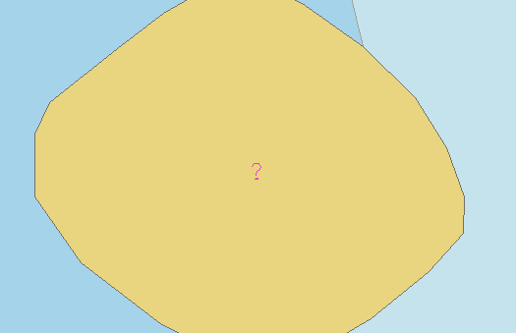
Expected Test Results | 101_1408: An error “Chart1Feature exists within the dataset but are prohibited for an ENC.” must be triggered.
Secondary Critical Errors | None

Dataset Name | 10100AA158006 |  | S‐158 Check |  | 101_1268 |  |  | Type |  | C
S-158 Description | For each Obstruction OR Wreck where valueOfSounding is Present AND height is Present.
Message | Obstruction or Wreck feature where valueOfSounding and height is Present.
Solution | Remove the value for either valueOfSounding or height |  |  |  | Conformity |  | PS 13.6
Test Case No. 1 | Obstruction or Wreck feature where valueOfSounding and height is Present.
Location | Feature | Attributes |  | FRID |  | FOID |  |  | VRID
32.4875919S, 61.4906630E | Wreck | height = 0.3 m  valueOfSounding = 1.2 m  waterLevelEffect = 1  surroundingDepth = 0.0 m |  | 72 |  | 1810:8668:1
Screen Capture | 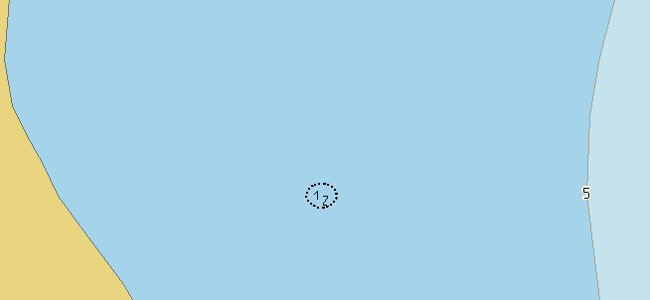
Expected Test Results | 101_1268: An error “Obstruction or Wreck feature where valueOfSounding and height is Present.” must be triggered.
Secondary Critical Errors | None

Dataset Name | 10100AA158006 |  | S‐158 Check |  | 101_1252 |  |  | Type |  | C
S-158 Description | For each Wreck where valueOfSounding is not Present AND categoryOfWreck is not Present.
Message | Wreck feature where neither valueOfSounding or categoryOfWreck is Present
Solution | Populate either valueOfSounding or categoryOfWreck. |  |  |  | Conformity |  | PS 13.5
Test Case No. 1 | Wreck feature where neither valueOfSounding or categoryOfWreck is Present.
Location | Feature | Attributes |  | FRID |  | FOID |  |  | VRID
32.4902697S, 61.4915452E | Wreck | categoryOfWreck = UNDEFINED  valueOfSounding = UNDEFINED  waterLevelEffect = 1  surroundingDepth = 0.0 m |  | 73 |  | 1810:8679:1
Screen Capture | 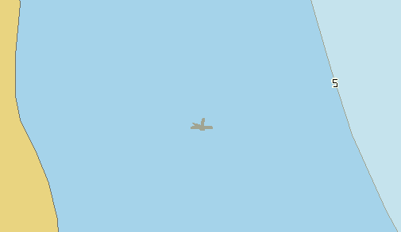
Expected Test Results | 101_1252: An error “Wreck feature where neither valueOfSounding or categoryOfWreck is Present” must be triggered.
Secondary Critical Errors | 101_1005

